Current Operable Unit 3 Remedial Progress for Week Ending 2/05/10
Creamer Environmental Inc., National Grid’s Remediation Contractor, is finishing the excavation and backfill where the LIRR tracks were relocated. To date, 214 trucks have transported approximately 5967.31 tons (3978.21cubic yards) of soil to Bay Shore Soil Management (formerly ESMI of NJ) for thermal desorption. Additionally 164,869 gallons of impacted excavation water has been disposed of at Clean Waters of Staten Island and Bridgeport United Recycling in Connecticut. Creamer Environmental has started the restoration task of Phase I, which will include the reconstruction of the sub-grade for the original LIRR track alignment and the removal of temporary facilities and controls.
GEI, National Grid’s Remediation Oversight Consultant, continues to perform Community Air Monitoring Program (CAMP), noise, and vibration monitoring. CAMP, noise, and vibration monitoring will stop the week beginning February 15th 2010 and will resume approximately April 26th 2010 for Phase II of the project.

Two-Week Outlook
Phase 1 restoration is anticipated to continue until mid to late February. Following the restoration portion of Phase I, the LIRR will begin to prepare for relocating the tracks back to their original alignment.
General hours of operation will continue to be Monday through Friday, 7:00 AM to 3:30 PM. However, work hours will be extended when necessary to maintain schedule or to complete critical tasks.

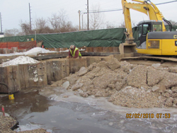
Removing sheet pile to design elevation and installing sub-grade

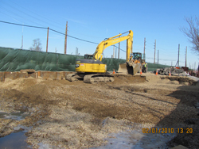
Installing sub grade materal
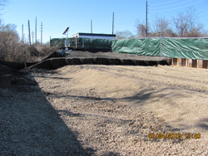
Installed sub grade for LIRR original alignment

